
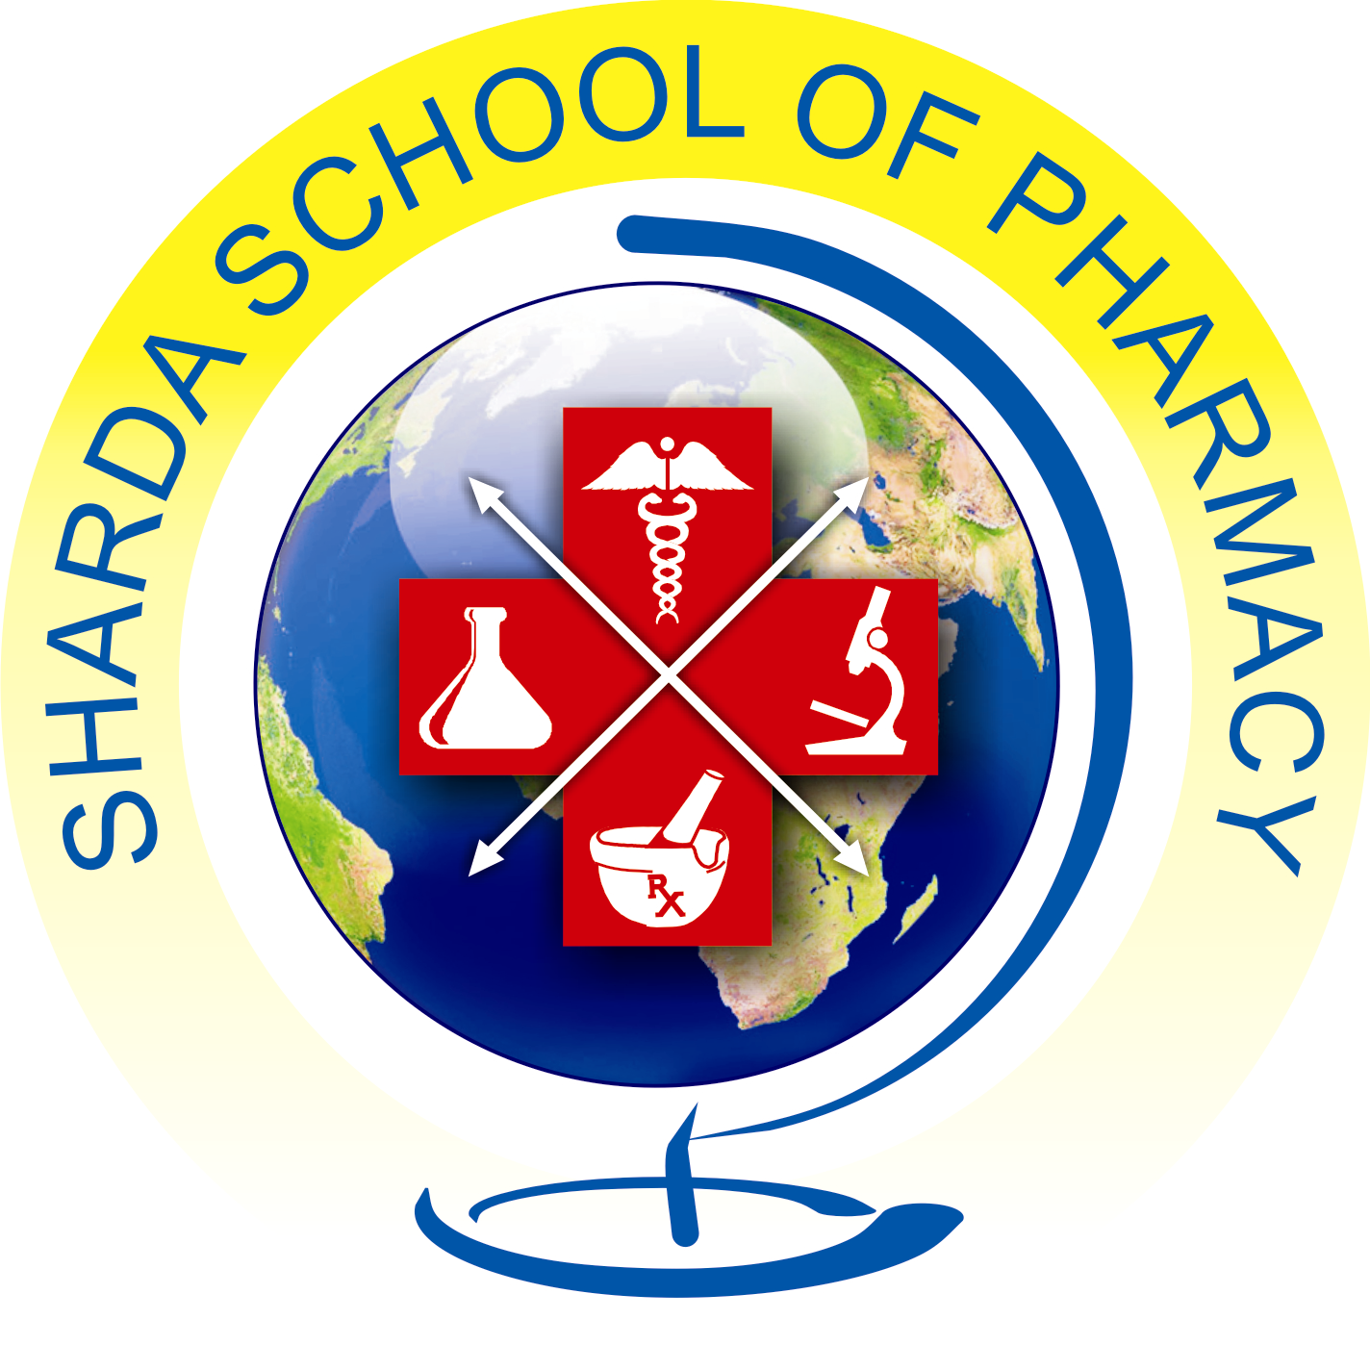
SSPIDEATHON
ORGANISED BY
SHARDA SCHOOL OF PHARMACY, PETHAPUR, GANDHINAGAR
On 20th February, 2026

PROGRAMME REPORT

Ideathons are dynamic events that bring together individuals or teams to generate innovative ideas and solutions. With the main purpose of fostering creativity and collaboration, ideathons provide a platform for students to pitch their ideas and receive valuable feedback.
Sharda School of Pharmacy, Pethapur, Gandhinagar has organized SSPIDEATHON 2K26 on 20th March, 2026.
Students of various colleges of Gujarat were participated in the SSPIDEATHON 2K26 with their respective ideas and innovation.
There is total 40 teams were participated from many different colleges.
All the students bring their ideas in different departments like Pharmaceutics, Pharmacognosy, Pharmaceutical chemistry and Pharmacology.
There are two types of competition were arranged i.e. oral presentation competition and poster presentation competition.
The program was initiated by breakfast at 9:30 am. All the participated delegates had breakfast and then the presentation was started.

GLIMPSE OF PRESENTATION
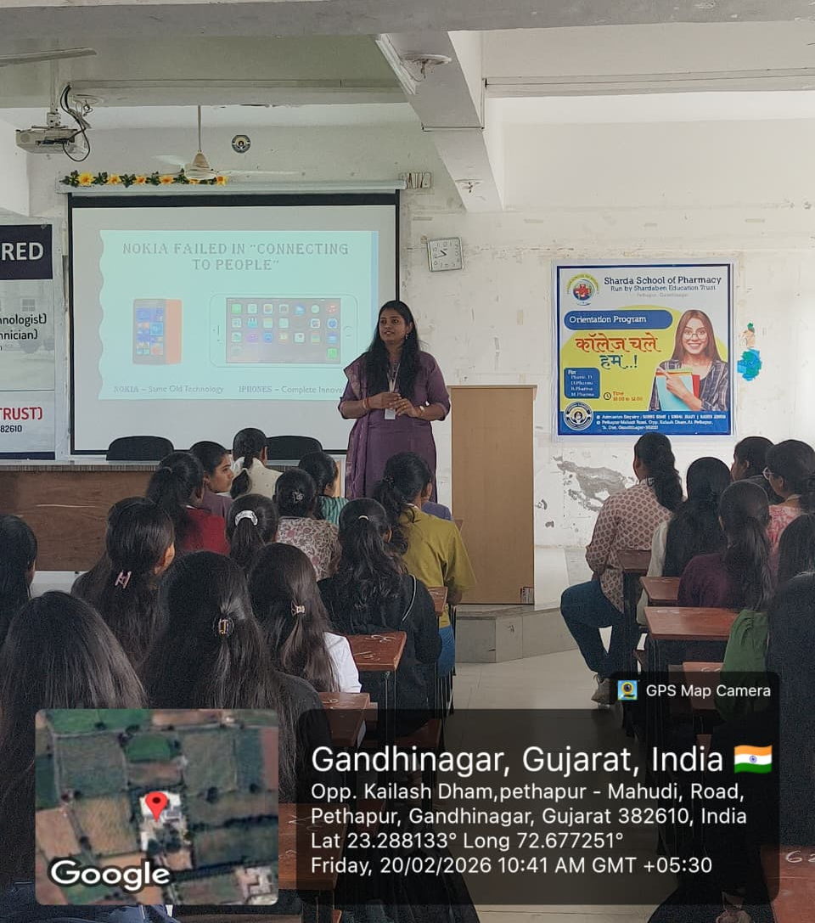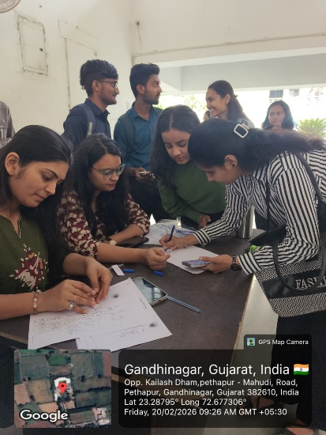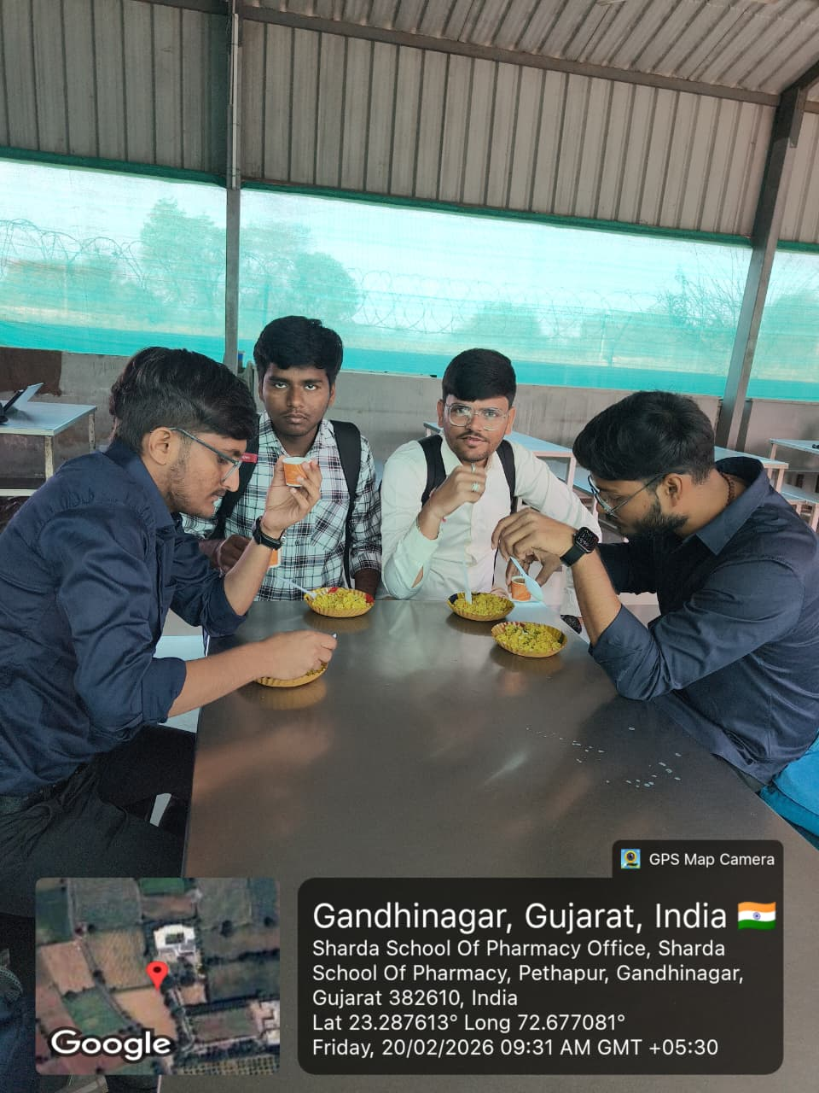

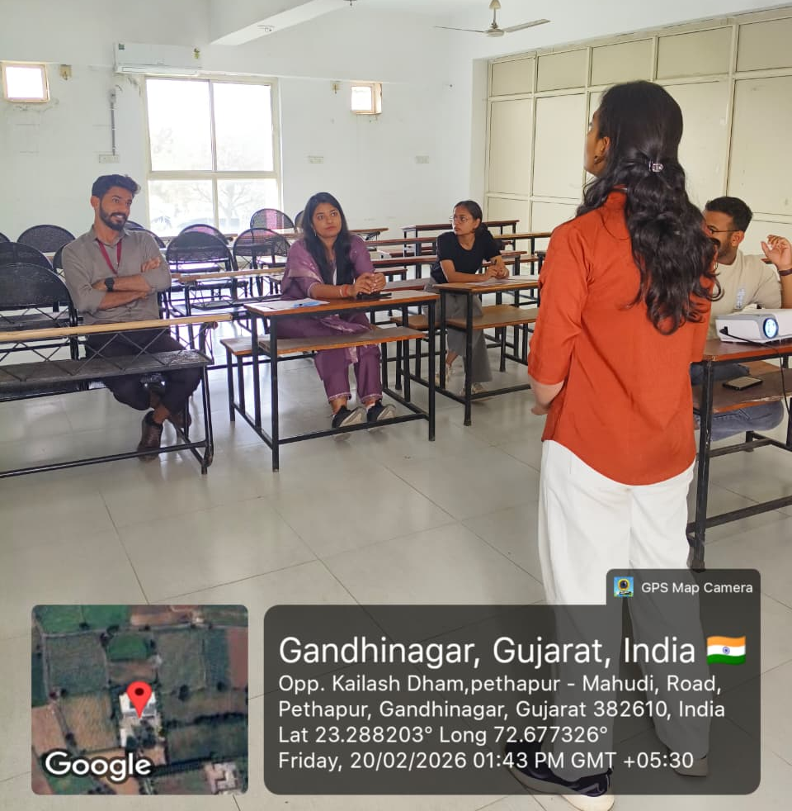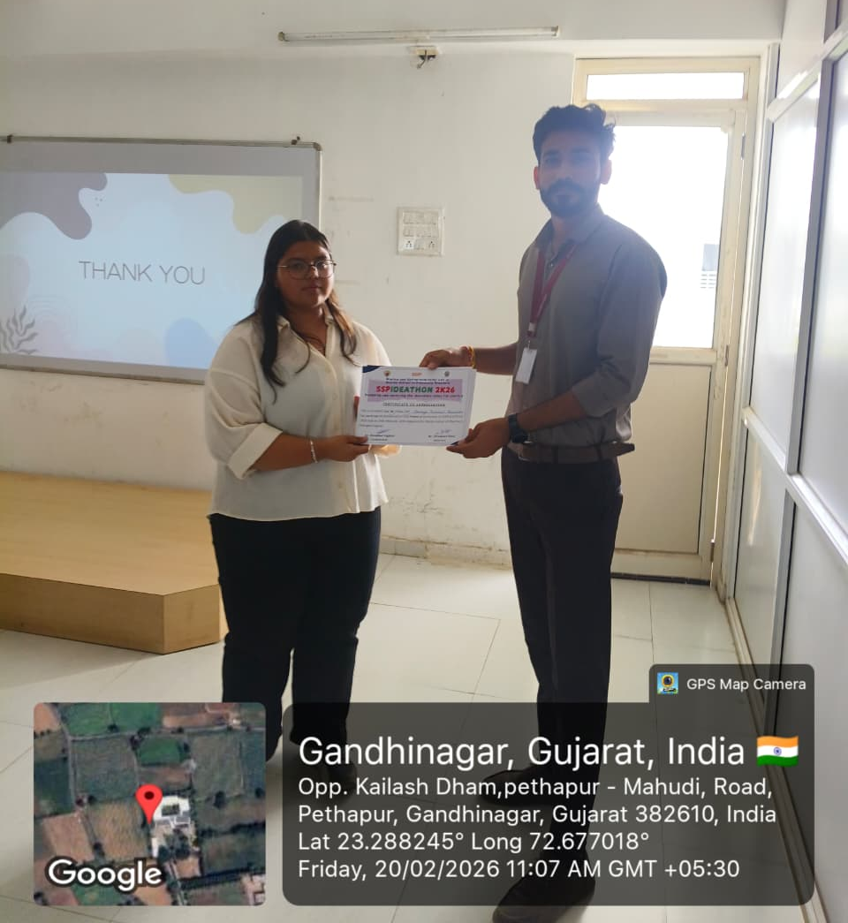

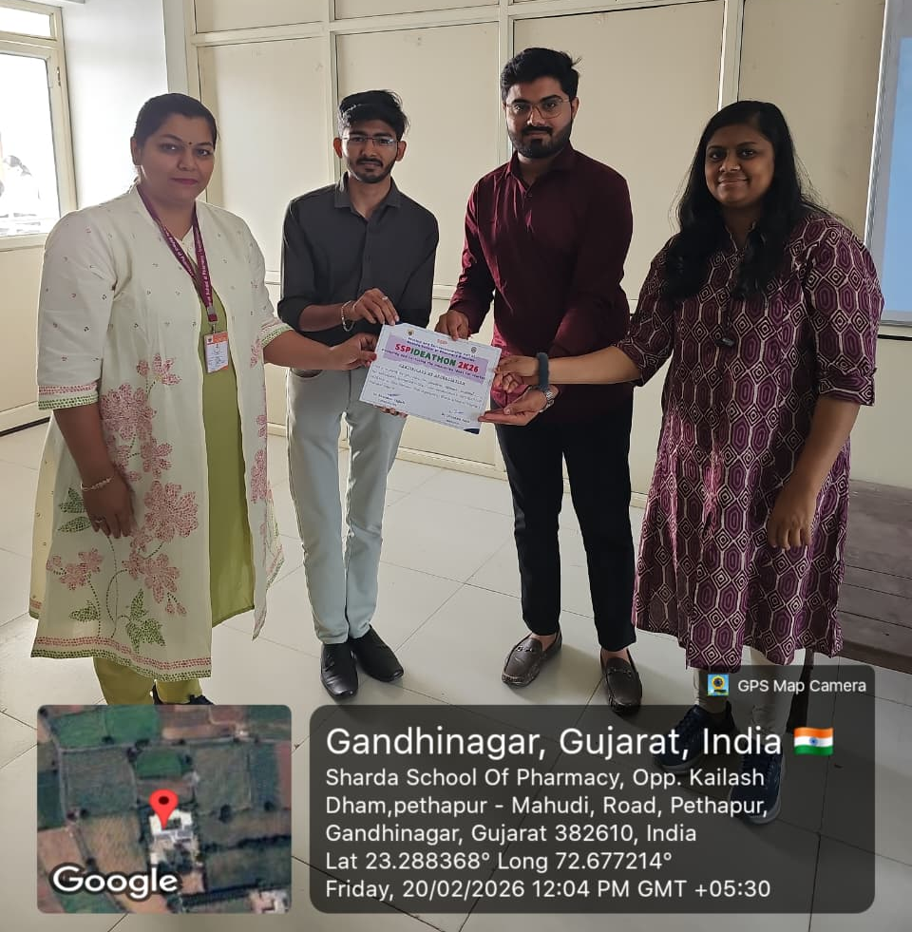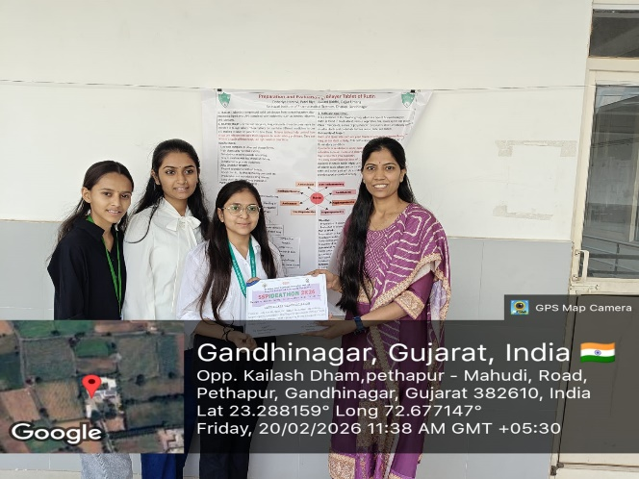

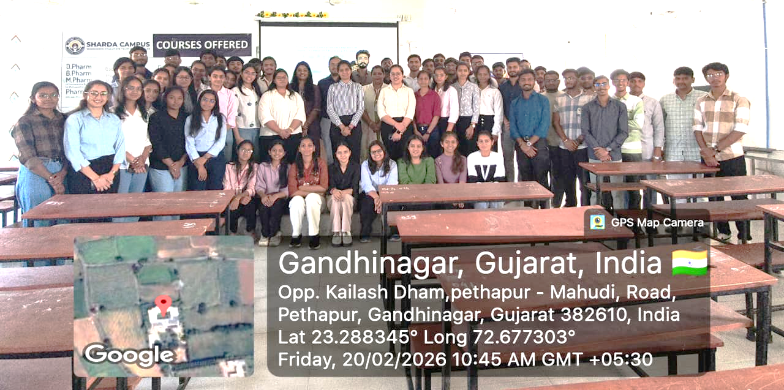

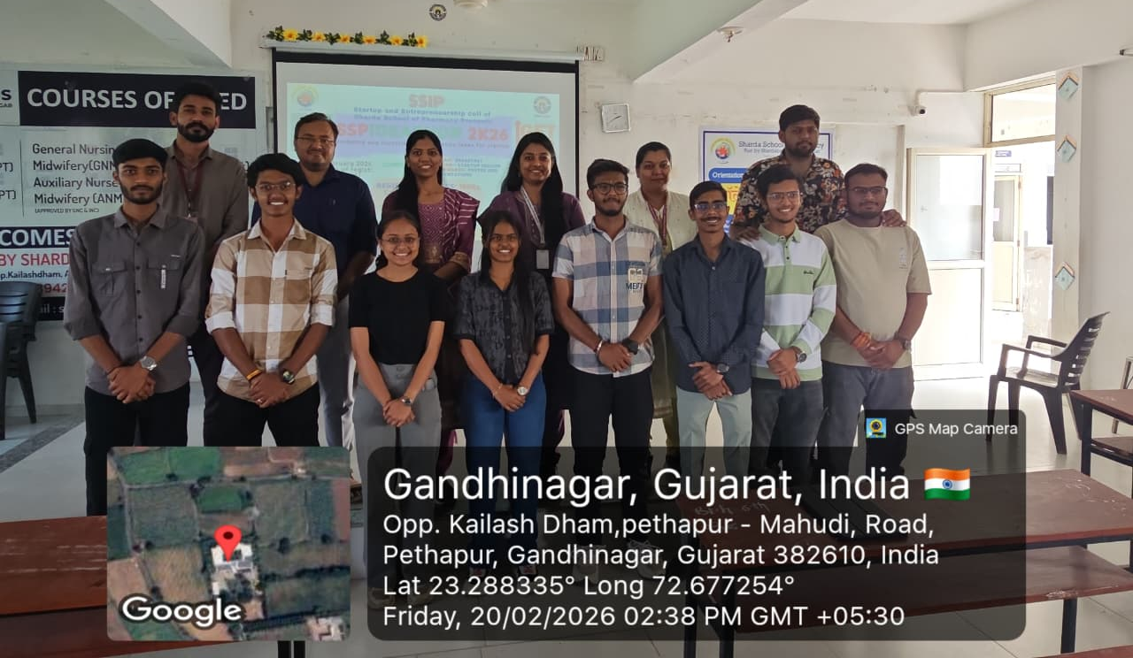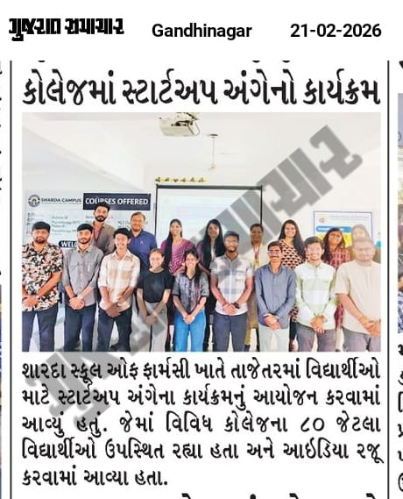

Sign of SSPIDEATHON Coordinators:
Sign of Principal:

